Algebra 1: Unit 10, Lesson 4

- Amalia started solving the absolute value equation. She found one solution.
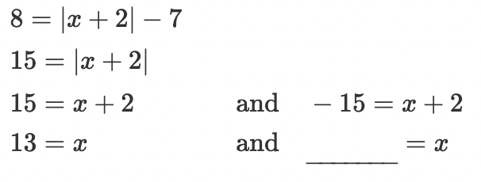
What is the other solution?
$$-17$$

- An absolute value equation is shown. Complete the table.
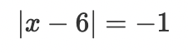
How many solutions does the equation have?
none

- The graph of the function $y=|x|-1$ is shown, along with the lines $y=-2$, $y=-1$, and $y=0$.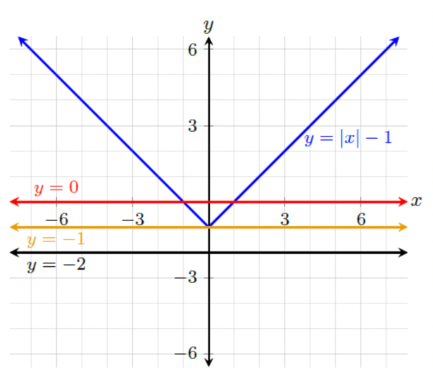
Complete the statements for the function $y=|x|-1$.
There are no values for $x$ such that _______________________.
$$y=-2$$

